PROFILE
Department | Electronics & Telecommunication Engg |  | 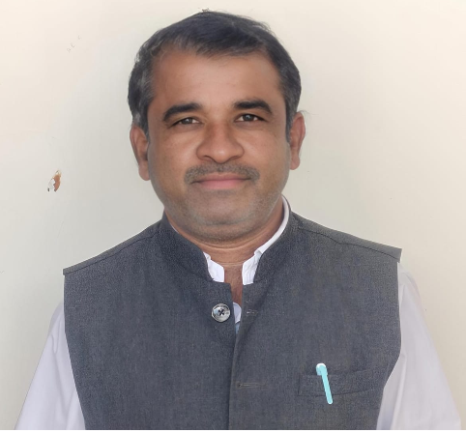
Title (Mr. / Mrs. / Miss / Dr. / Prof.) | Mr
First name | Ravindra
Middle name | Bhika
Surname | Phase
Designation | Assistant Professor
UG degree | B.E. Electronics & Telecommunication Engineering
UG University | Sant Gadge Baba Amravati University, Amravati.
UG Division | First
PG Degree | M. E. Digital Electronics
PG University | Sant Gadge Baba Amravati University, Amravati.
PG Division | First
PhD (Yes / No / Pursuing) | -
Highest Degree (Post Graduate / Graduate) | Post Graduate
Other Qualifications | -
Email | ravindra.phase@aecc.ac.in
Experience (Teaching) | 18 Year
Experience (Industry) | --
Publications | Published 3 Papers in International Journal and 1 online Book Published.
Papers Presented in conference | National Journal: | 0
Papers Presented in conference | International Journal: | 3
Books Published | 1 Books Published
STTP/ FDP Attended | 07
Number of PhD, M.Phil, M.Tech Guided | --

Mr. Ravindra Bhika Phase
Assistant Professor

