PROFILE
Department | Computer Science and Engineering |  | 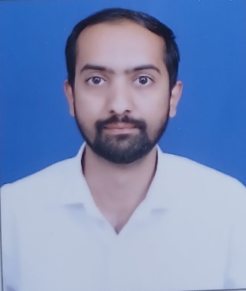
Title (Mr. / Mrs. / Miss / Dr. / Prof.) | Mr. Shivam Nilesh Chopda
First name | Shivam
Middle name | Nilesh
Surname | Chopda
Designation | Assistant professor
UG degree | B-Tech (IT)
UG University | Savitribai Phule Pune University
UG Division | FIRST Class with Distinction
PG Degree | --
PG University | --
PG Division | --
PhD (Yes / No / Pursuing) | No
Highest Degree (Post Graduate /  Graduate) | B-Tech
Other Qualifications | Diploma In Civil Engineering
Email | Shivamchopda04@gmail.com
Experience (Teaching) | 04 Months
Experience (Industry) | 06 Months
Publications | 01
Papers Presented in conference | National: --
Papers Presented in conference | International:01
Books Published | --
STTP/ FDP Attended | --
Number of PhD, M.Phil, M.Tech Guided | --

Prof.S.N.Chopda
Assistant Professor
(CSE Dept.)

