PROFILE
Department | Mechanical Engineering |  | 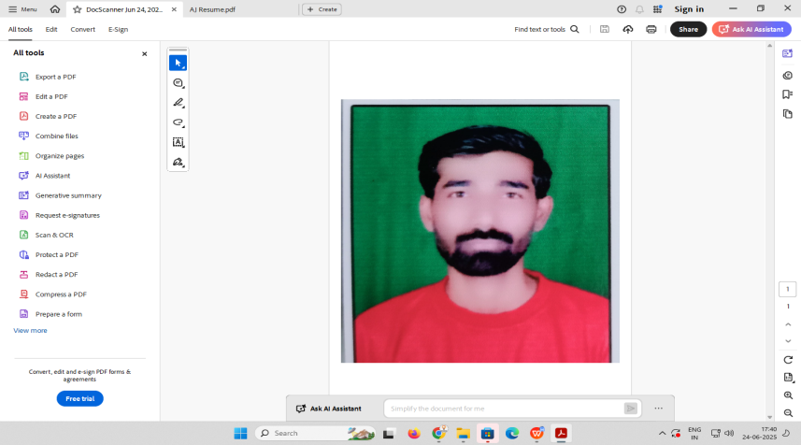
Title(Mr. /Mrs. /Miss/Dr./Prof.) | Mr.
Firstname | Ajay
Middlename | Gajanan
Surname | Sulakhe
Designation | AssistantProfessor
UGdegree | B.E.Mechanical Engineering
UGUniversity | Sant Gadge Baba Amravati University, Amravati.
UGDivision | Frist
PGDegree | --
PGUniversity | --
PGDivision | --
PhD(Yes/No/Pursuing) | --
HighestDegree(PostGraduate/Graduate) | Under Graduate
OtherQualifications | --
Email | ajaysulakhe2086@gmail.com
Experience(Teaching) | 2 Year
Experience(Industry) | --
Publications | --
PapersPresentedinconference | National Journal: | --
 | International Journal: | --
BooksPublished | --
STTP/ FDP Attended | --
Number ofPhD,M.Phil,M.TechGuided | --

Mr. Ajay G. Sulakhe
Assistant Professor (Mech.Engg)

