PROFILE
Department | InformationTechnology |  | 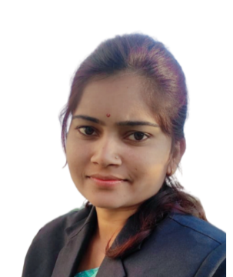
Title(Mr. /Mrs. /Miss/Dr./Prof.) | Miss.
Firstname | VAISHALI
Middlename | D.
Surname | PARIHAR
Designation | AssistantProfessor
UGdegree | B.E.Information Technology
UGUniversity | Sant Gadge Baba Amravati University, Amravati.
UGDivision | Frist
PGDegree | M. E. Computer Sci. & Engineering – Pursuing
PGUniversity | Sant Gadge Baba Amravati University, Amravati.
PGDivision | --
PhD(Yes/No/Pursuing) | --
HighestDegree(PostGraduate/Graduate) | Under Graduate
OtherQualifications | --
Email | vaishaliparihar00@gmail.com
Experience(Teaching) | 1Year
Experience(Industry) | --
Publications | --
PapersPresentedinconference | National Journal: | 01
 | International Journal: | 04
BooksPublished | --
STTP/ FDP Attended | --
Number ofPhD,M.Phil,M.TechGuided | --

Miss.Vaishali D. Parihar
Assistant Professor (IT)

