PROFILE
Department | Electronics & Telecommunication |  | 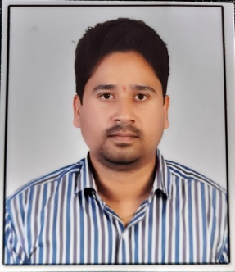
Title (Mr. / Mrs. / Miss / Dr. / Prof.) | Mr.
First name | Akash
Middle name | Ashok
Surname | Magar
Designation | Assistant Professor
UG degree | B.E. Electronics & Telecommunication Engg
UG University | Sant Gadge Baba Amravati University, Amravati.
UG Division | Frist
PG Degree | M. E. Electronics & Telecommunication
PG University | Dr. Babasaheb Ambetkar Marathwada University Sambhaji Nagar
PG Division | Frist
PhD (Yes / No / Pursuing) | --
Highest Degree (Post Graduate / Graduate) | Post Graduate
Other Qualifications | -
Email | akashmagar82@gmail.com
Experience (Teaching) | 8 Year
Experience (Industry) | --
Publications | --
Papers Presented in conference | National Journal: | --1
 | International Journal: | --4
Books Published | 02
STTP/ FDP Attended | --02
Number of PhD, M.Phil, M.Tech Guided | --

Mr. Akash A.Magar
Assistant Professor

