PROFILE
Department | Electronics & Telecommunication |  | 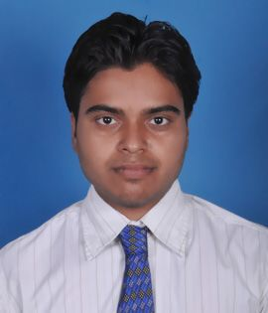
Title (Mr. / Mrs. / Miss / Dr. / Prof.) | Mr.
First name | Swapnil
Middle name | Haribhau
Surname | Kudke
Designation | Assistant Professor
UG degree | B.E. Electronics & Telecommunication Engg
UG University | Sant Gadge Baba Amravati University, Amravati.
UG Division | Frist
PG Degree | M. E. Digital Electronics
PG University | Sant Gadge Baba Amravati University, Amravati.
PG Division | Frist
PhD (Yes / No / Pursuing) | --
Highest Degree (Post Graduate / Graduate) | Post Graduate
Other Qualifications | Diploma in Electronics
Email | Swapnil.kudke@aecc.ac.in
Experience (Teaching) | 13 Year
Experience (Industry) | --
Publications | --
Papers Presented in conference | National Journal: | --1
 | International Journal: | --5
Books Published | 02
STTP/ FDP Attended | --13
Number of PhD, M.Phil, M.Tech Guided | --

Mr. Swapnil H. Kudke
Assistant Professor

