PROFILE
Department | Computer Science and Engineering |  | 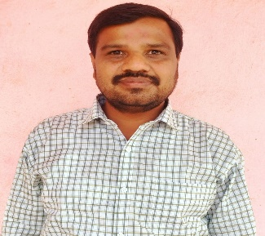
Title (Mr. / Mrs. / Miss / Dr. / Prof.) | Mr.
First name | KRUSHNA
Middle name | SHALIKRAM
Surname | TELANGRE
Designation | Assistant Professor
UG degree | B.E. Computer Science and Engineering
UG University | Sant Gadge Baba Amravati University, Amravati.
UG Division | Frist
PG Degree | M. E. Computer Sci. & Engineering – Pursuing
PG University | Sant Gadge Baba Amravati University, Amravati.
PG Division | --
PhD (Yes / No / Pursuing) | --
Highest Degree (Post Graduate / Graduate) | Under Graduate
Other Qualifications | --
Email | krushna.telangre@aecc.ac.in
Experience (Teaching) | 11 Year
Experience (Industry) | --
Publications | --
Papers Presented in conference | National Journal: | 4
 | International Journal: | --
Books Published | --
STTP/ FDP Attended | 4
Number of PhD, M.Phil, M.Tech Guided | --

Mr. Krushna S. Telangre
Assistant Professor (CSE)

