PROFILE
Department | Computer Science Engineering |  | 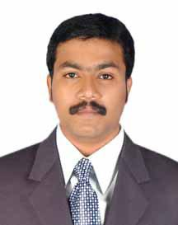
Title (Mr. / Mrs. / Miss / Dr. / Prof.) | Dr.
First name | SANTHAM
Middle name | BHARATHY
Surname | ALAGARSAMY
Designation | Dean of Research & Development and Assistant Professor
UG degree | B.E. ExTC
UG University | Anna University, Chennai
UG Division | Frist
PG Degree | M. E. VLSI Design
PG University | Anna University, Chennai
PG Division | Frist
PhD (Yes / No / Pursuing) | Yes
Highest Degree (Post Graduate / Graduate) | PhD
Other Qualifications | Pursuing Post Doctorate in Malaysiya
Email | santham.alagarsamy@aecc.ac.in
Experience (Teaching) | 6 Years
Experience (Industry) | 1 Year
Publications | 13
Papers Presented in conference | National Journal: | Nil
 | International Journal: | 08
Books Published | 01
STTP/ FDP Attended | 05
Number of PhD, M.Phil, M.Tech Guided | Nil

Dr.Santham Bharathy Alagarsamy,
Assistant Professor (CSE)

