PROFILE
Department | Chemical Engineering |  | 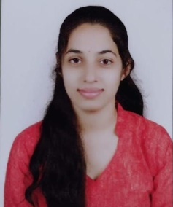
Title (Mr. / Mrs. / Miss / Dr. / Prof.) | Miss
First name | Sakshi
Middle name | S
Surname | Baniya
Designation | Assistant Professor
UG degree | B.Tech. Chemical Engineering
UG University | KBCNMU,Jalgaon
UG Division | First
PG Degree | M. Tech. Chemical Engineering – Pursuing
PG University | Sant Gadge Baba Amravati University, Amravati.
PG Division | --
PhD (Yes / No / Pursuing) | --
Highest Degree (Post Graduate / Graduate) | Graduate
Other Qualifications | --
Email | sakshi.baniya@aecc.ac.in
Experience (Teaching) | 2.5 Year
Experience (Industry) | --
Publications | --
Papers Presented in conference | National Journal: | --
 | International Journal: | 01
Books Published | --
STTP/ FDP Attended | 03
Number of PhD, M.Phil, M.Tech Guided | --

Miss. Sakshi S. Baniya
Assistant Professor (CHEMICAL)

